`

CAN WE FORECAST THE PERSPECTIVE OF UPCOMING CUSTOMER REVIEWS LEVERAGING NEURAL NETWORKS, AND MORE ESPECIALLY NATURAL LANGUAGE PROCESSING (NLP), USING PREVIOUS SENTIMENT ANNOTATED SETS OF DATA?

TASK 2

D213

STUDENT NAME: IBRAHIM SULEIMAN

DATA ANALYTICS

STUDENT NUMBER: 001429984

COLLEGE OF INFORMATION TECHNOLOGY, WESTERN GOVERNORS UNIVERSITY

NAME OF INSTRUCTOR: DANIEL SMITH

NOVEMBER 27TH, 2022

Part 1: Research Question

A1. Research Question:

Can we forecast the perspective of upcoming customer reviews leveraging neural networks, and more especially Natural Language Processing (NLP), using previous sentiment annotated sets of data?

A2. Goal

In this report, we'll utilize the Python TensorFlow library to create a model that forecasts the tone of upcoming customer reviews based on previously provided labeled datasets. One of the objectives of the data analysis was to analyze and comprehend the clients by determining which product they liked based on favorable product evaluations.

A3. Type Of Neural Network:

Sentiment analysis concentrates on the polarity of a text, whether it be positive, negative, or neutral, but extends beyond polarity of angry, delighted, sad, urgency; imperative, fairly immediate emergency, and even intentions; interested vs. indifferent. (MonkeyLearn).

For my Natural Language Processing (NLP) model, I'll utilize the Python TensorFlow and Keras libraries since sentiment analysis using an NLP model will be the most effective method for deciphering the emotions included in text data. The purpose of the data analysis is to create a model to forecast the tone of upcoming customer reviews using labeled data from the past. Additionally, by determining the customer's chosen product through good product evaluations, the company may better understand its clients.

Part 2: Data Preparation

B1. Exploration of Data

Three labeled datasets from Amazon, IMDB, and Yelp will be combined into a single data frame for the analytic process. the following

• Collection of Amazon Product data

• Collection of UCSD Recommender Systems data

• Collection of UCI Sentiment Labeled Sentences data

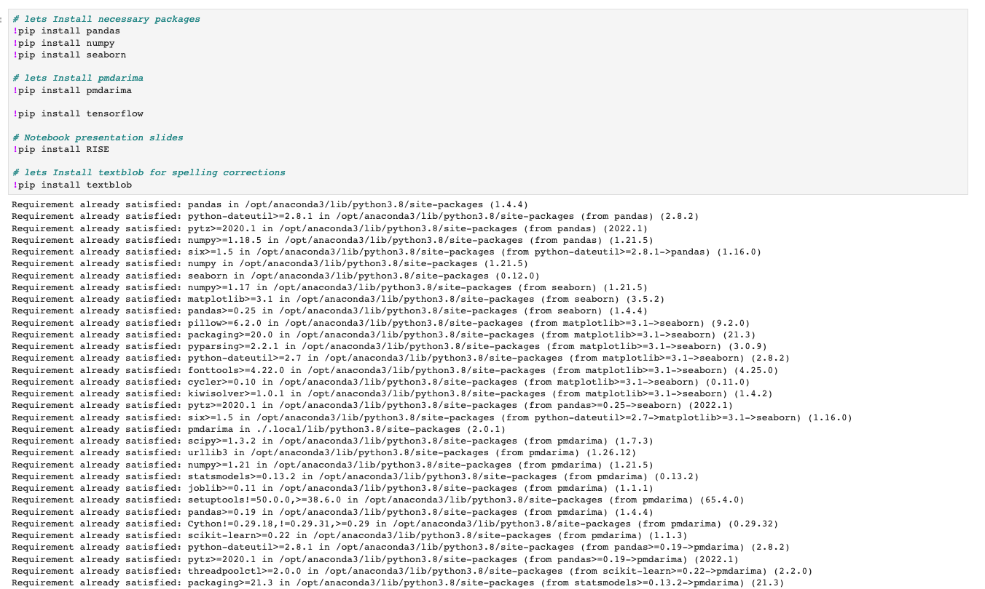

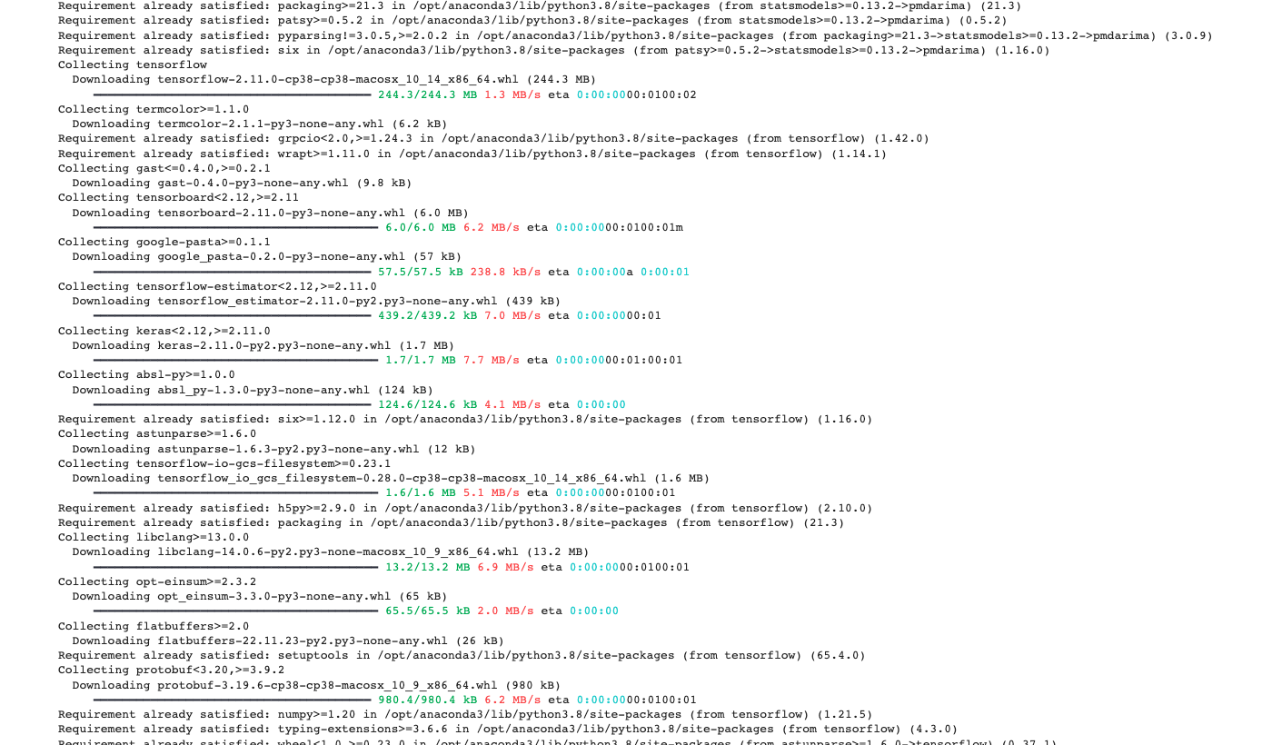

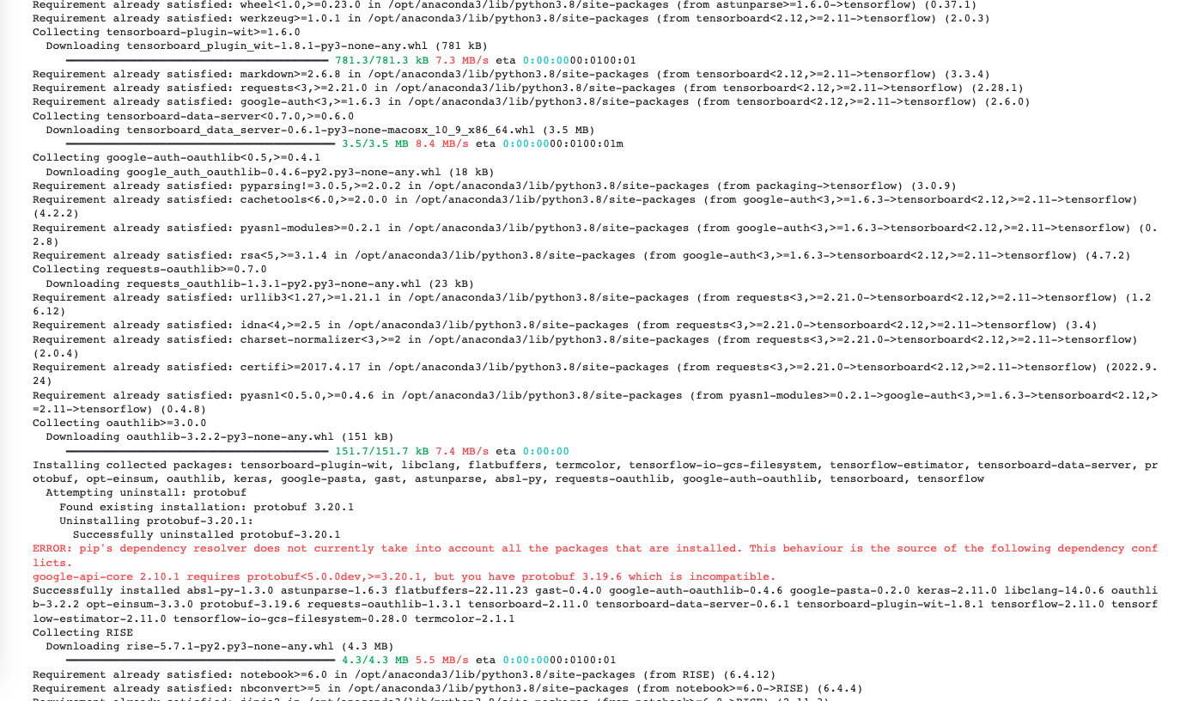

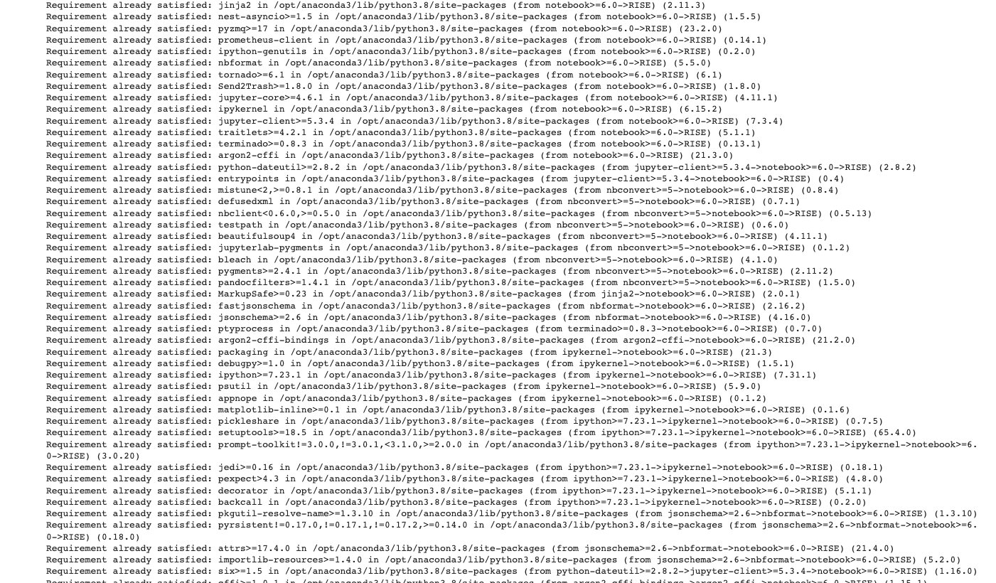

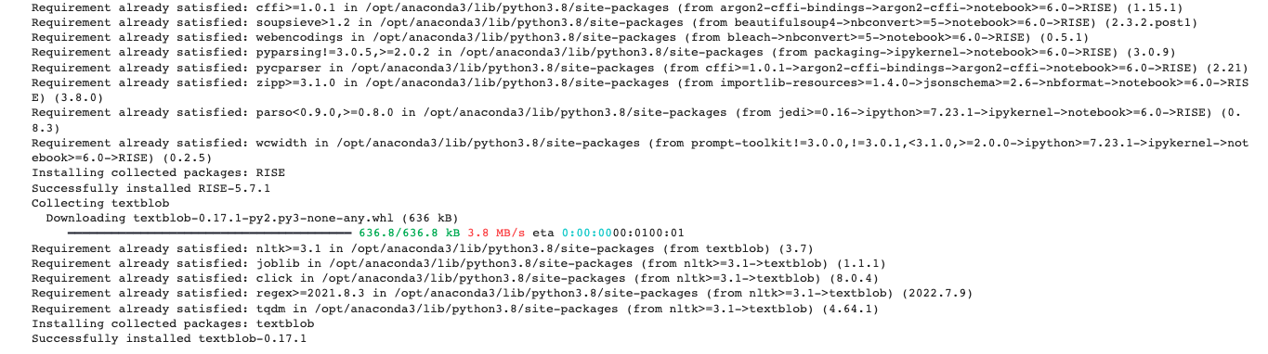

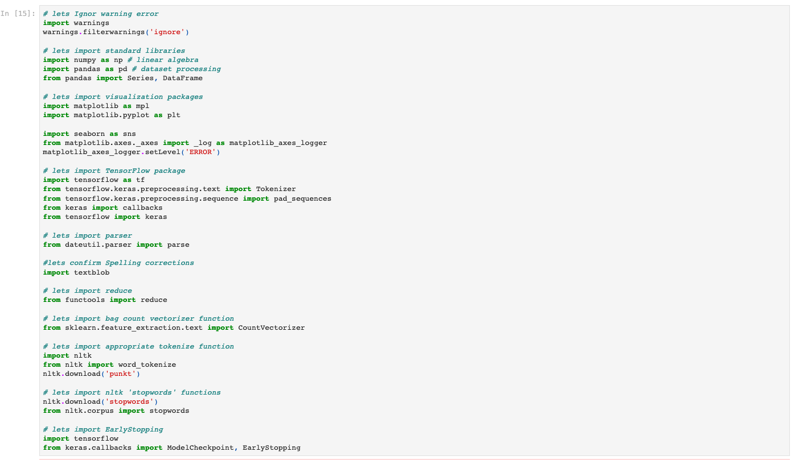

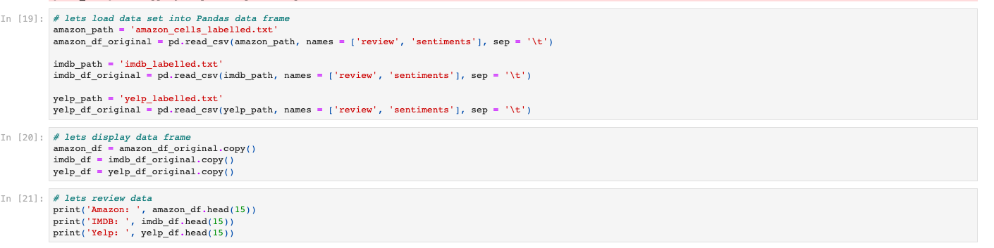

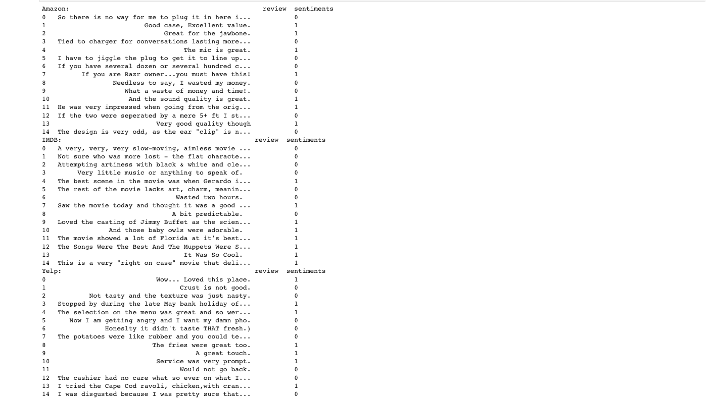

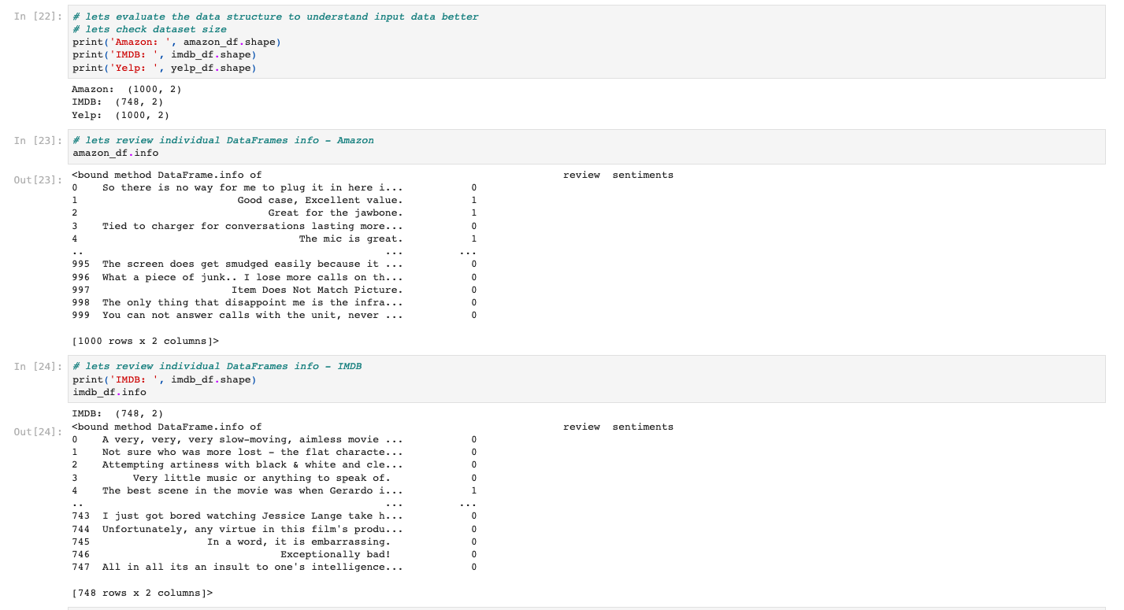

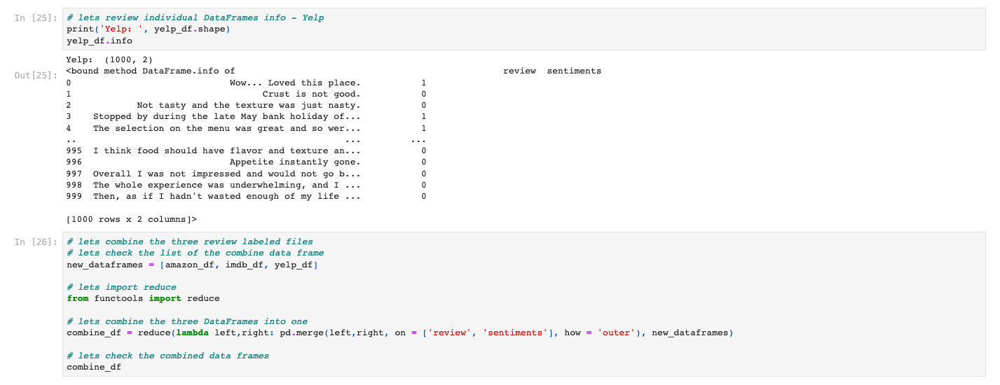

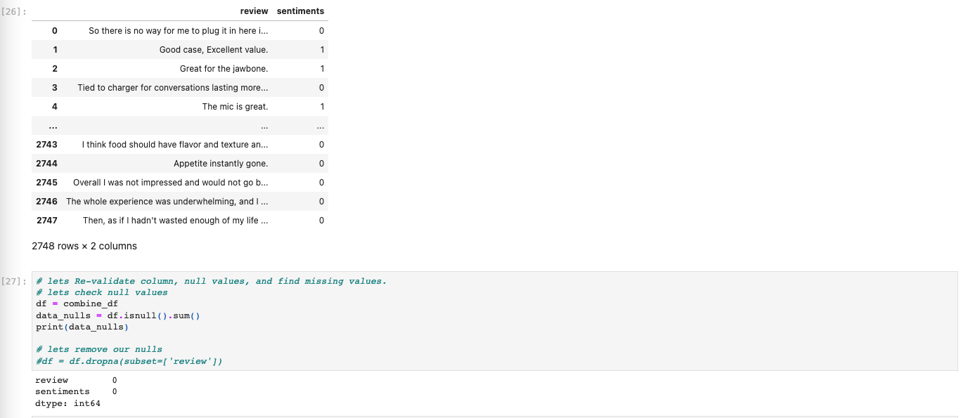

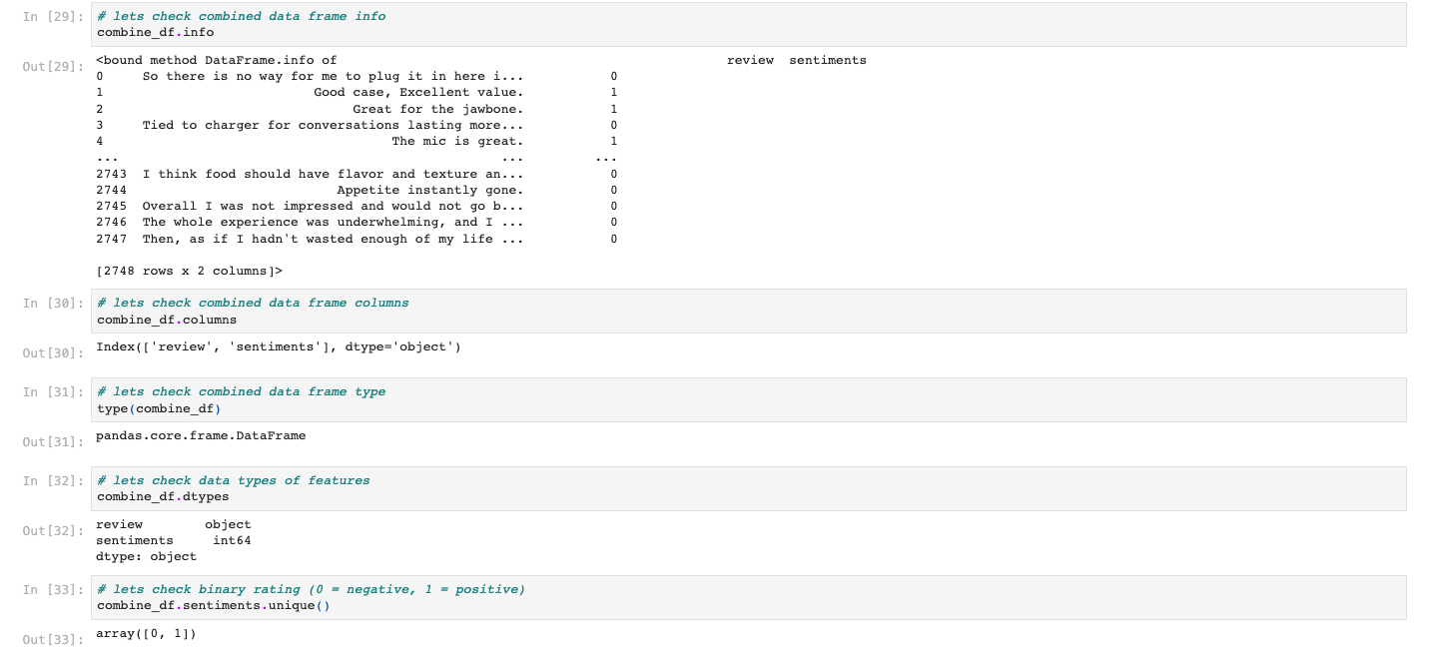

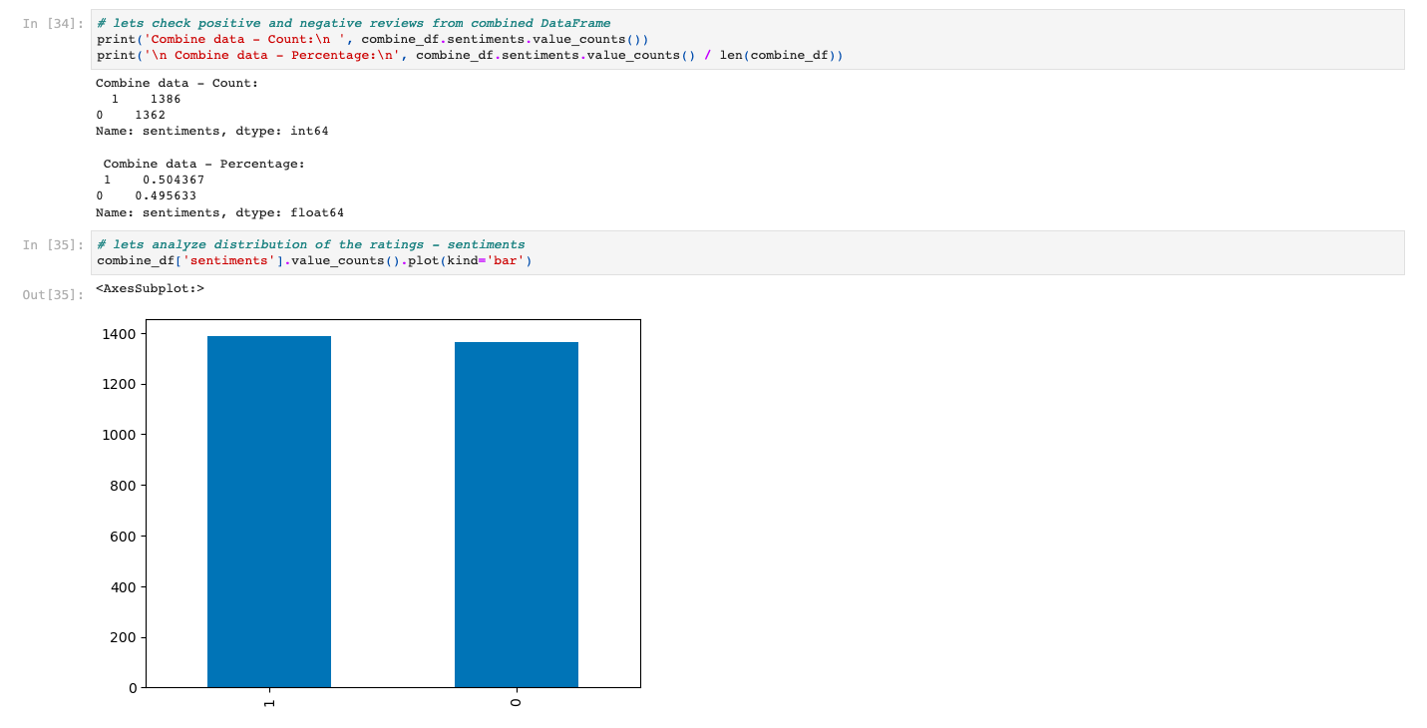

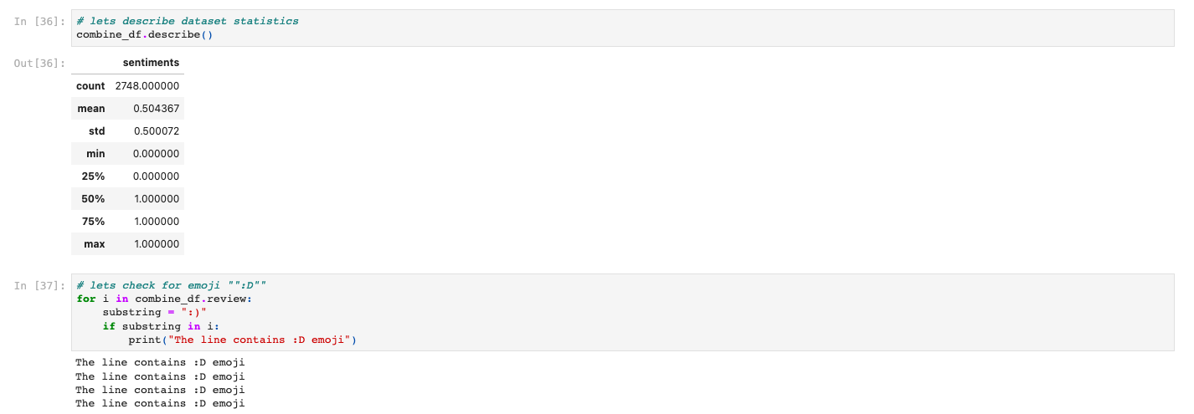

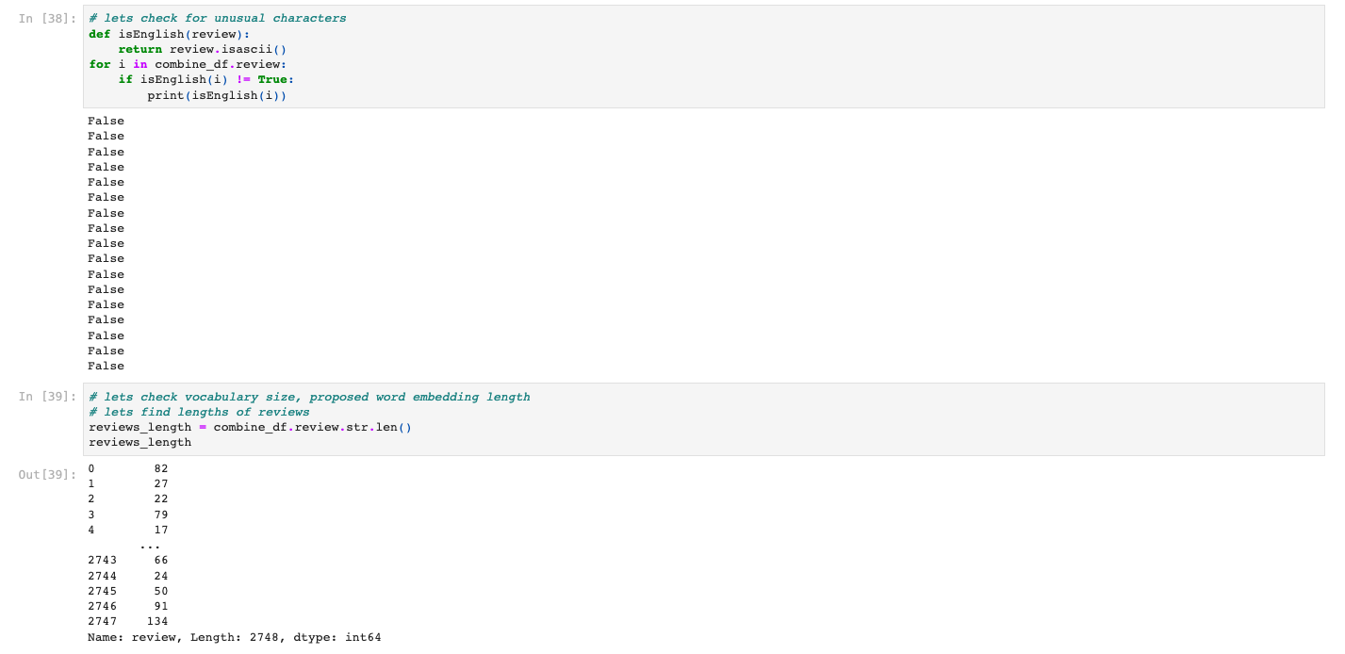

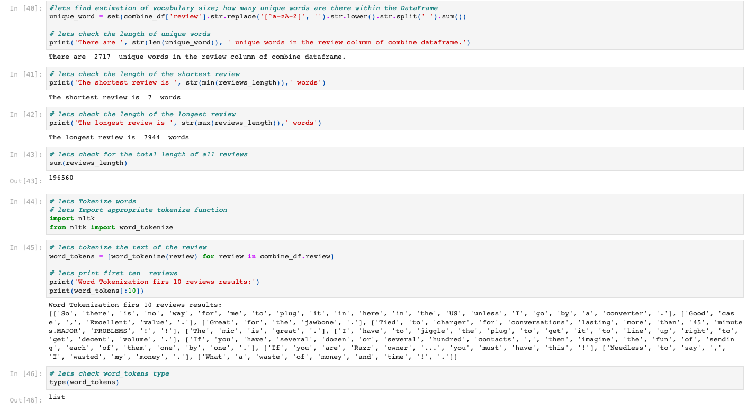

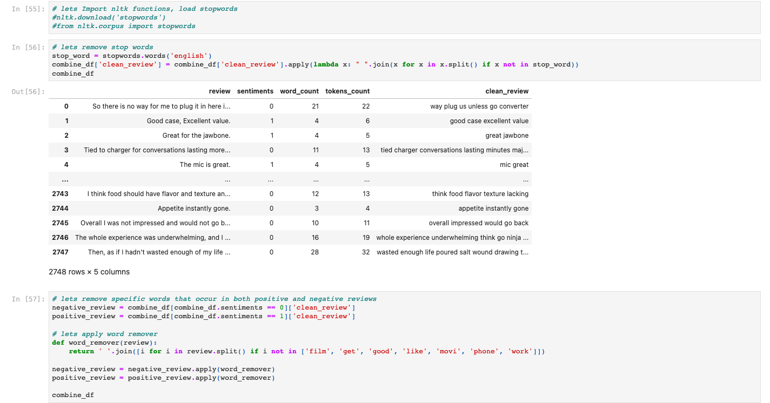

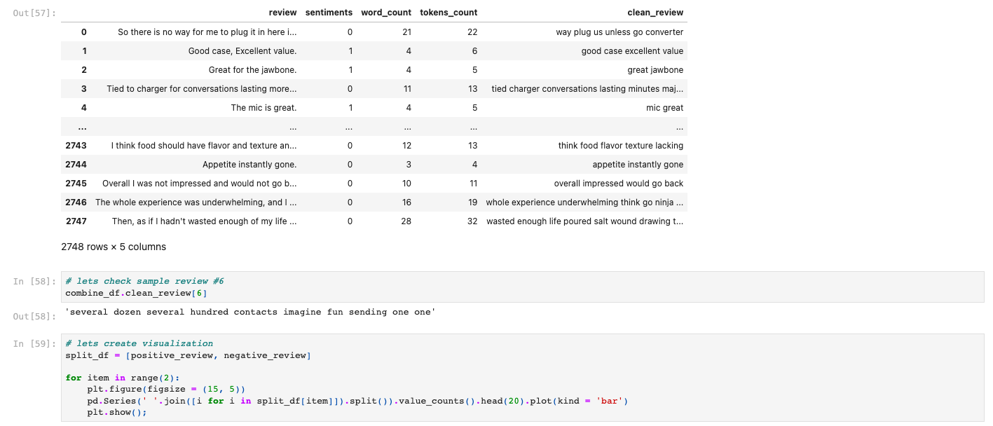

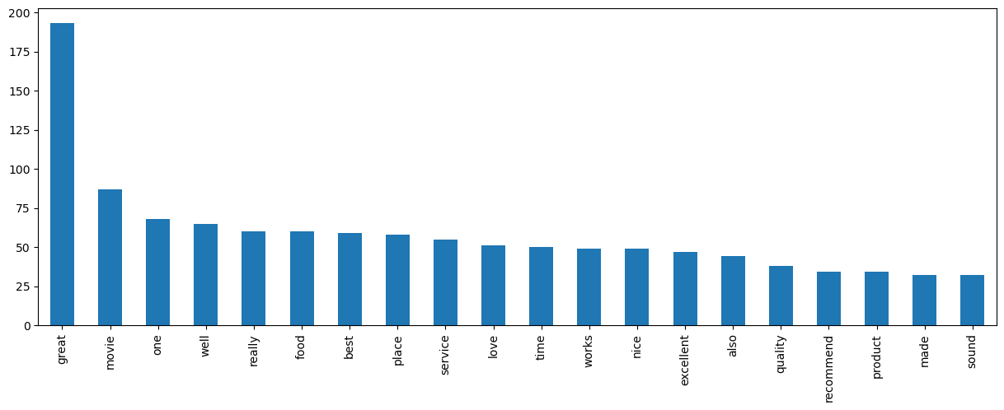

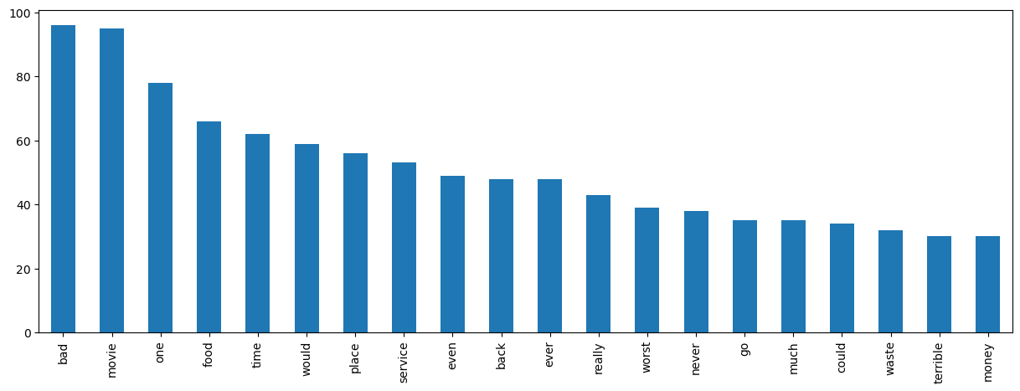

B2. The Tokenization Process

Tokenization is the process of dividing a written document into tokens, which are very little pieces of text. A token might be a word, a word fragment, or merely a letter, such a period. (Tal, 2021) The core of NLP analysis is the tokenization procedure. It explains the process of separating the text or phrase into so-called tokens for analysis and aids in our understanding of it. For the tokenization procedure, Scikit-Learn, TensorFlow, and Keras are utilized. The tokenization procedure is detailed below. Using the parameter

* Vacab_size is practicing at 2200 words, which is the model's maximum allowed for unique word use.
* embedding_dim is 16 dimensions
* max_length of each customer review is restricted to 100 words.
* trunc_type 'post' is the truncation type if the word count reaches 100.
* oov_tok is not sufficient to replace the foreign terms with
* padding_type is used at the review's conclusion; the padding style is ‘post.’

In [44]:

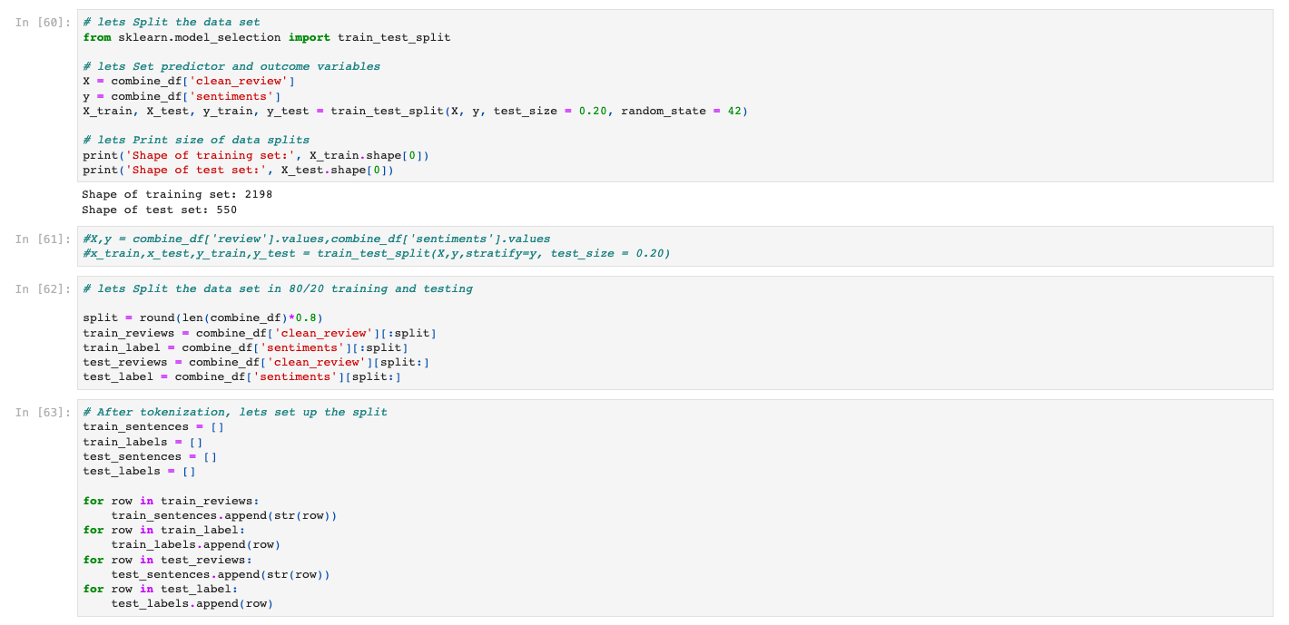

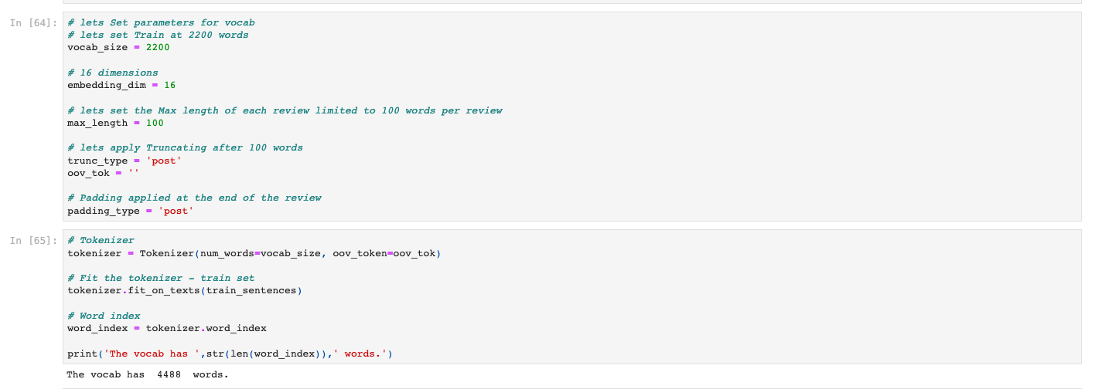

B3. Padding Method

In this assignment, we use the Keras padding method and the post-argument to pad the end of sentences that are shorter than 100 words in length.

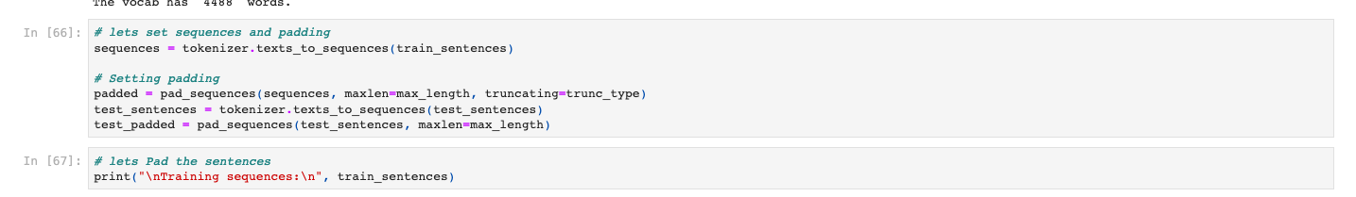

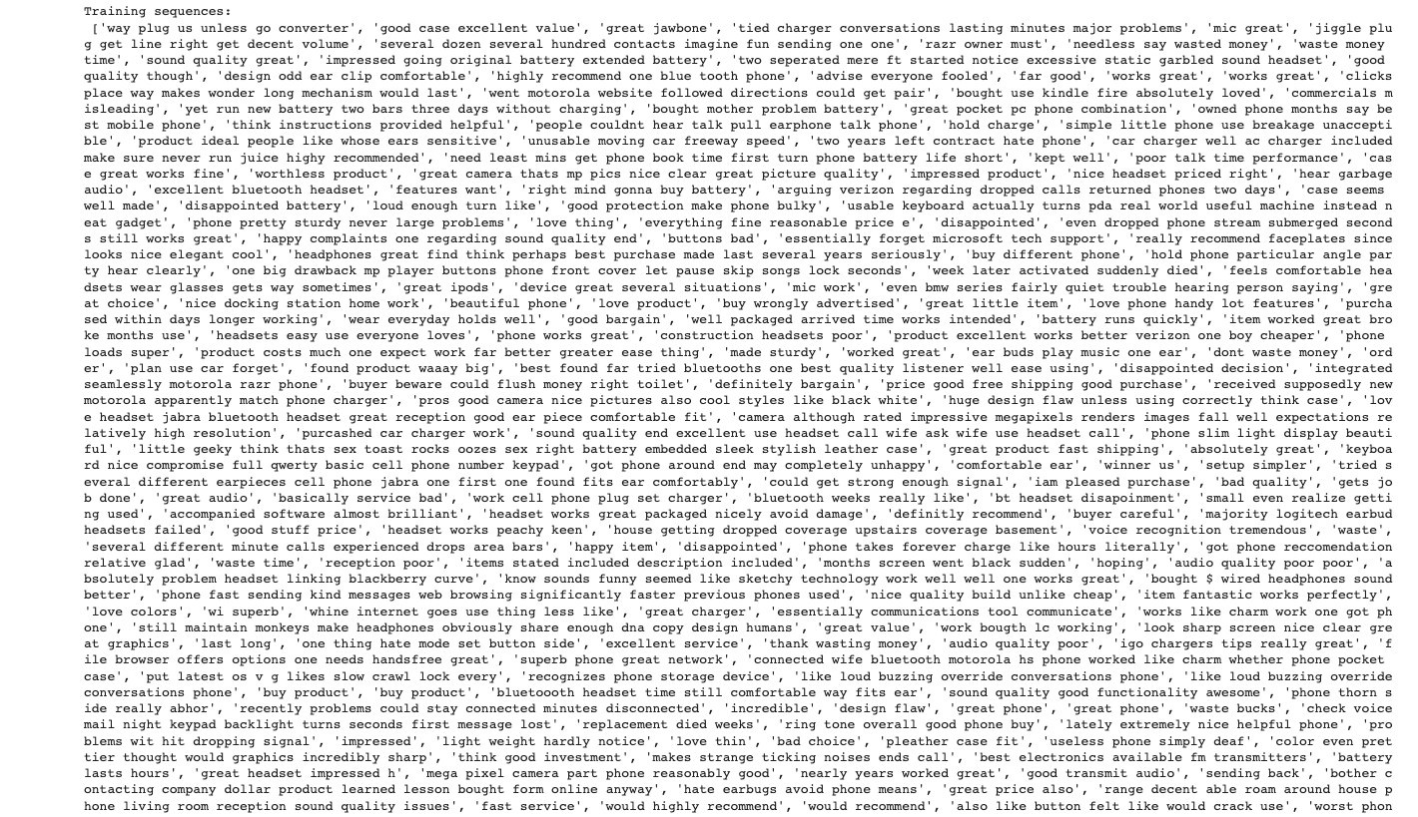

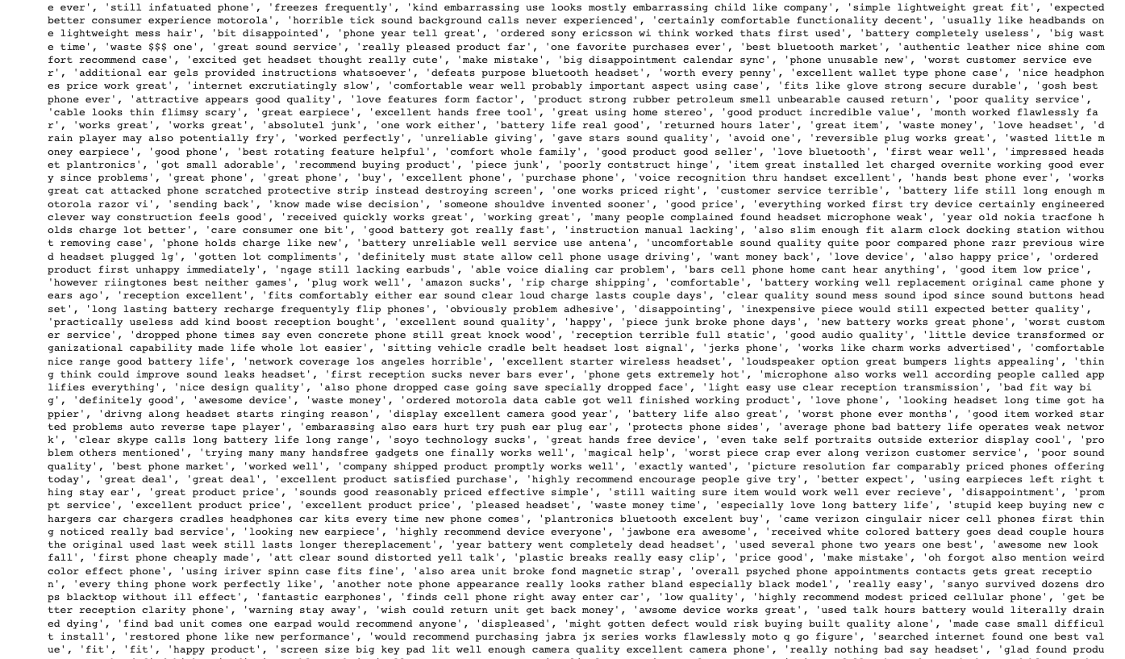

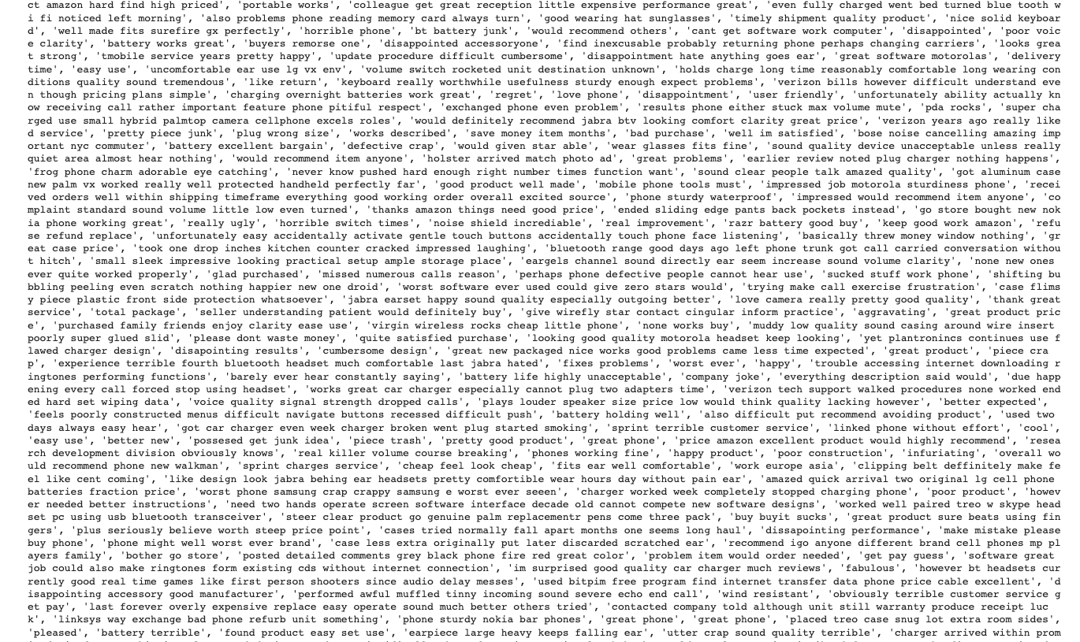

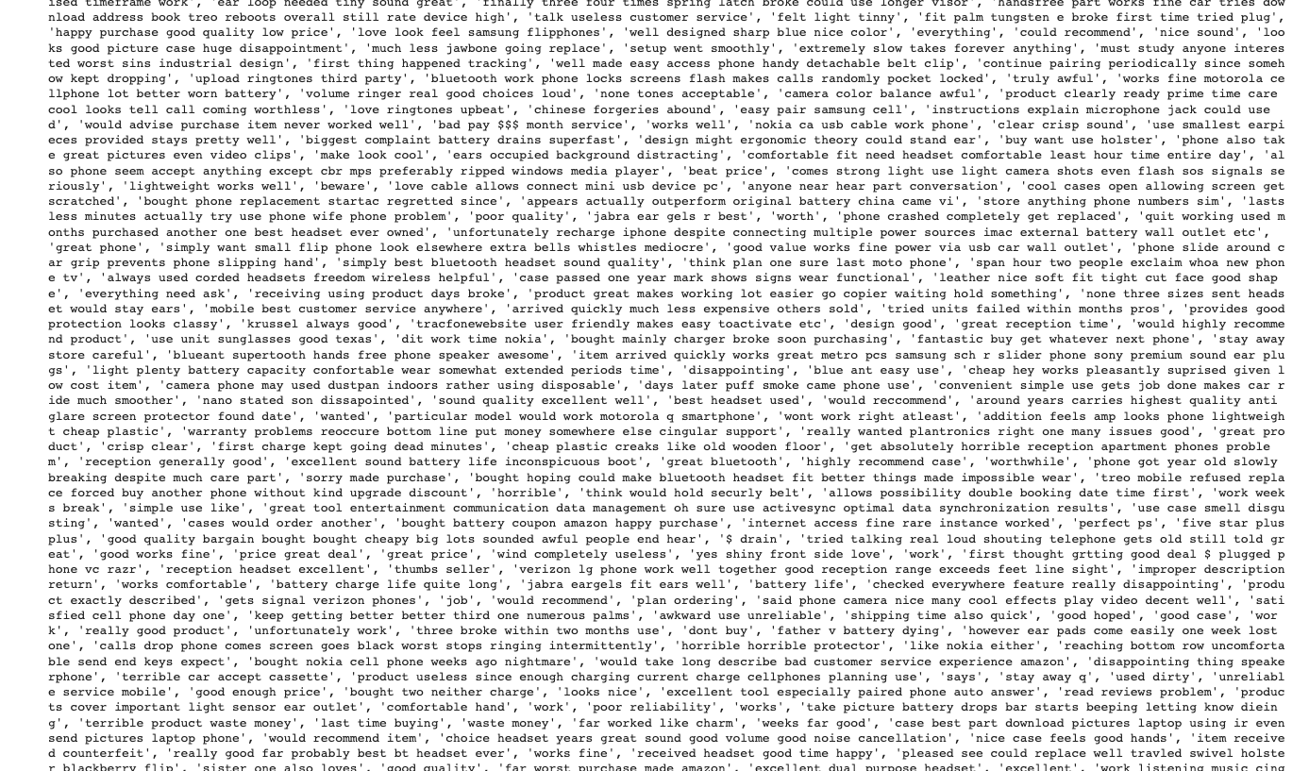

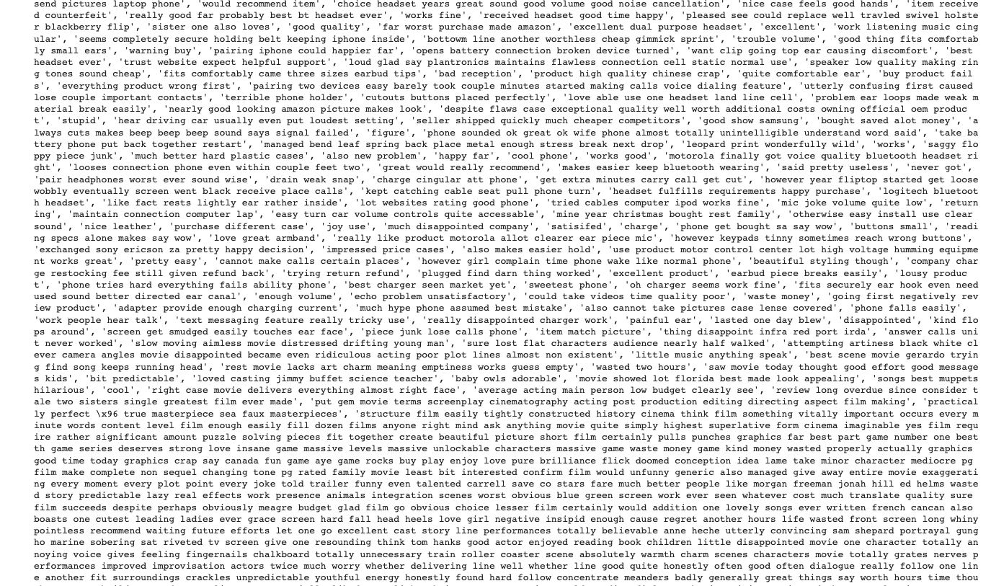

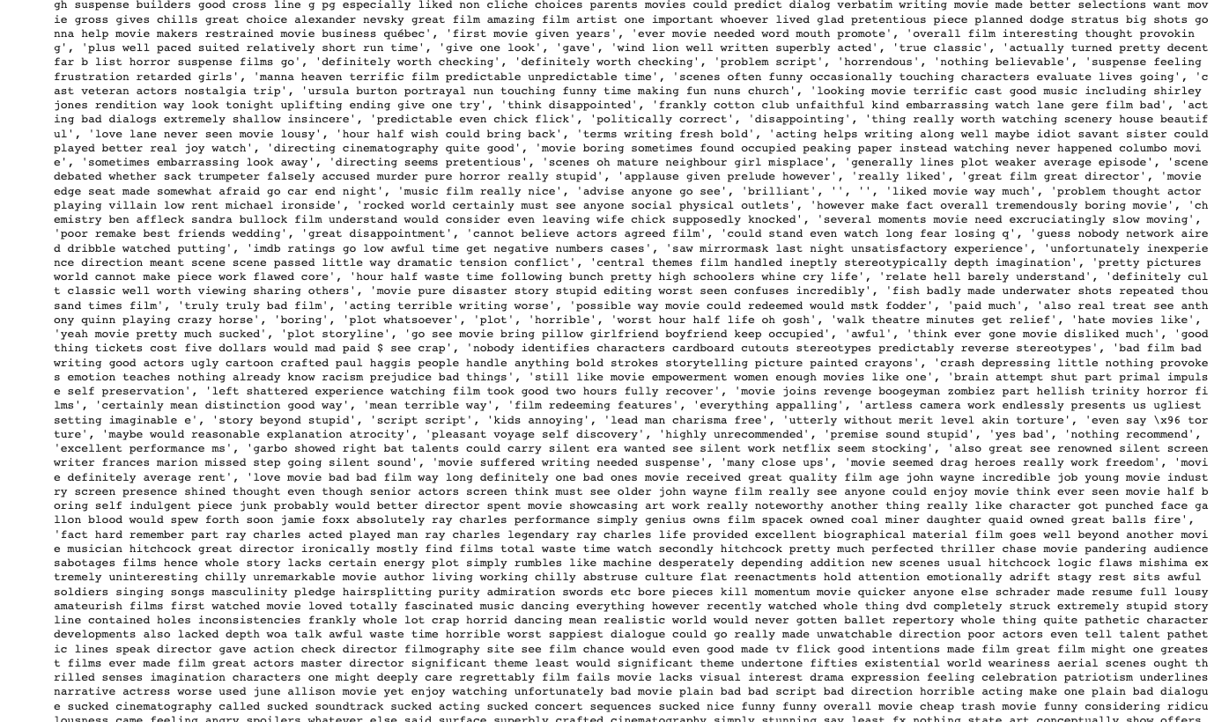

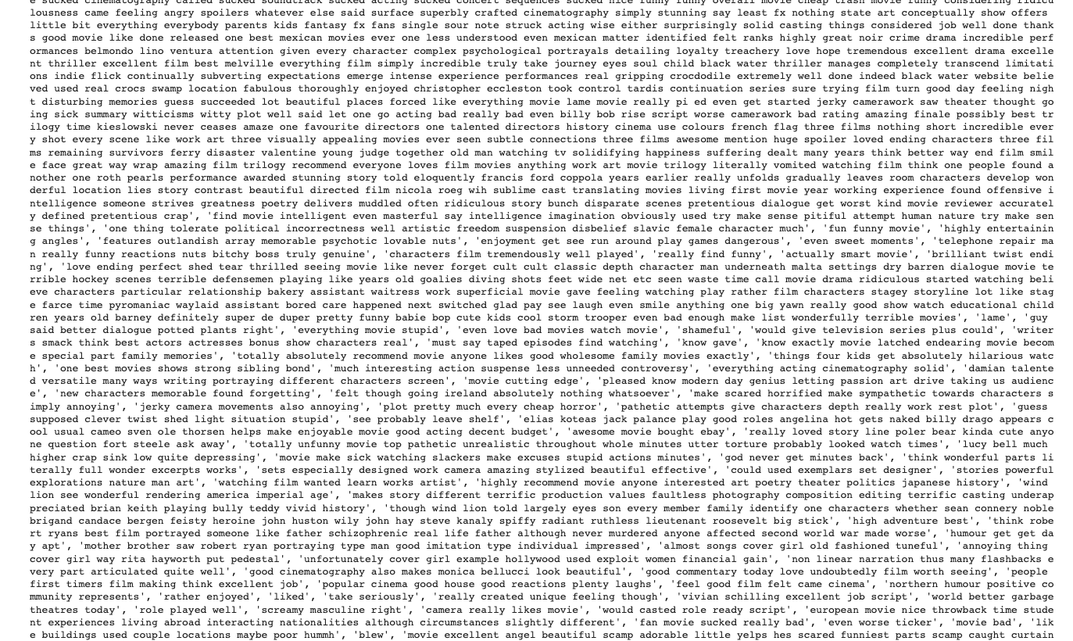

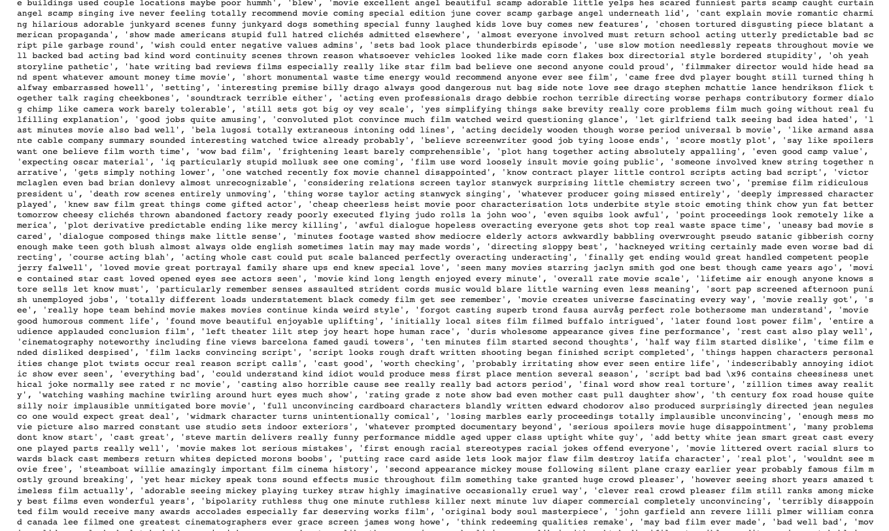

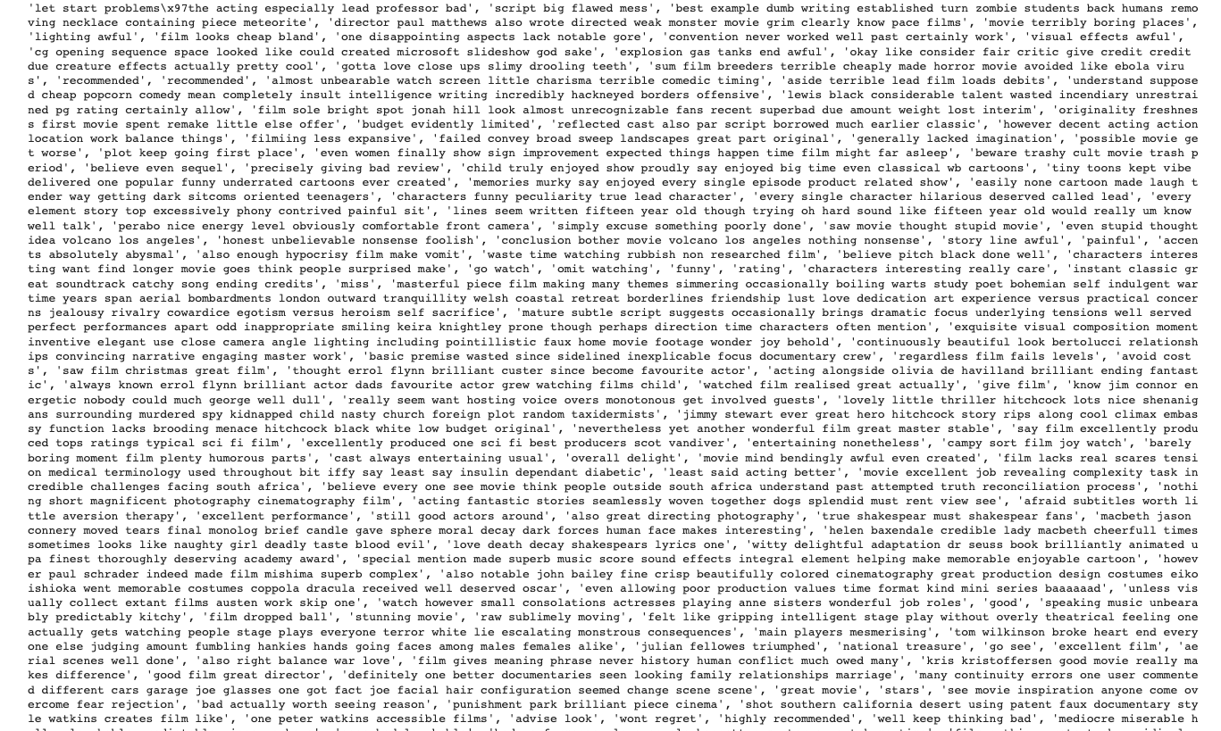

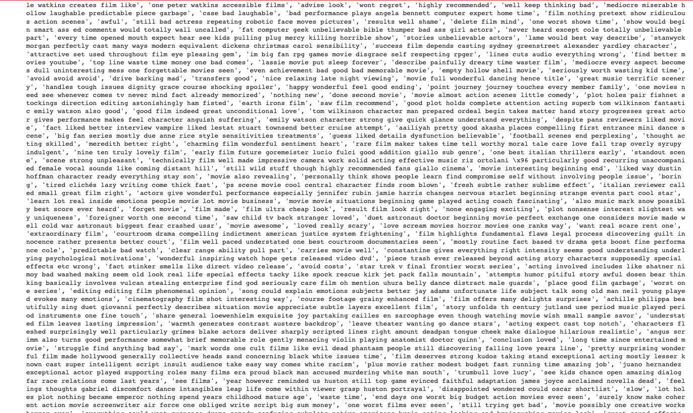

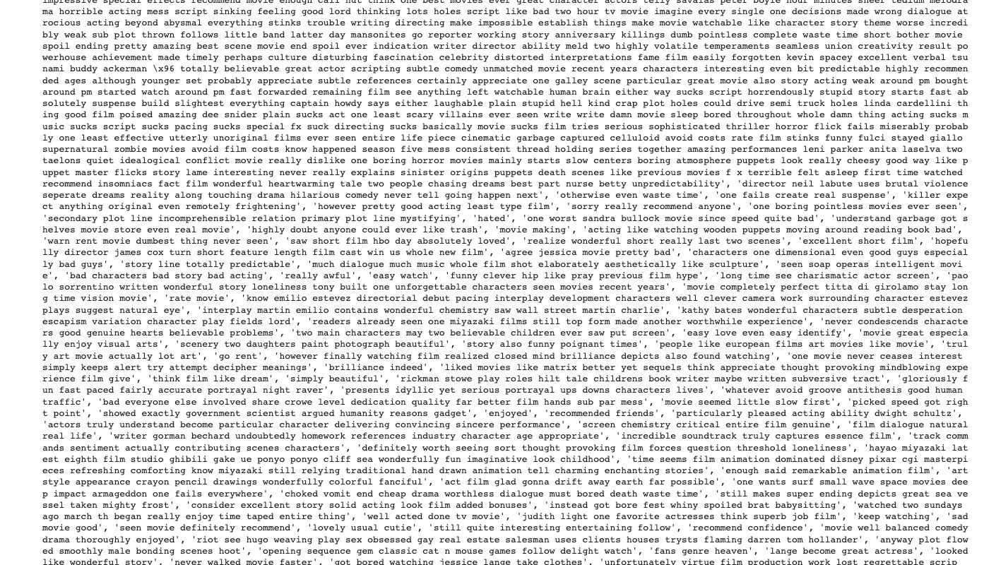

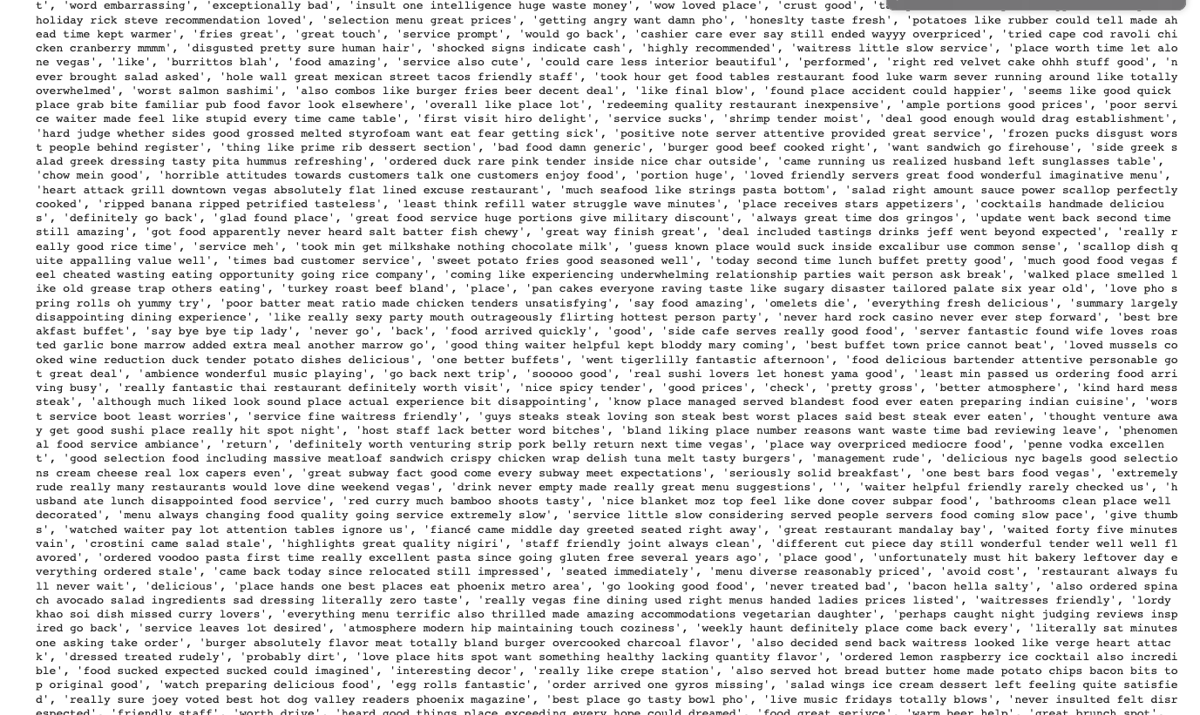

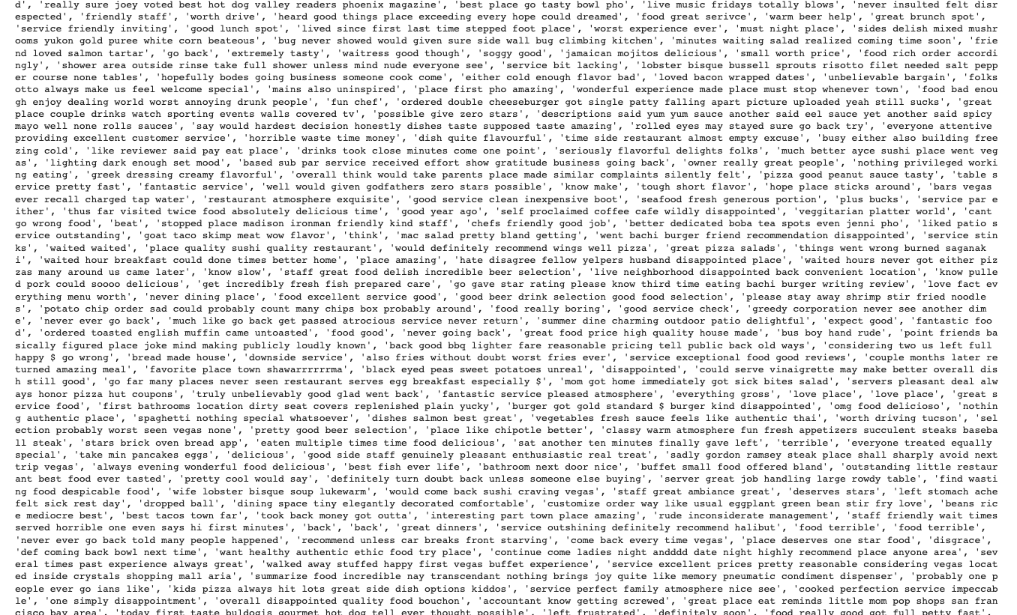

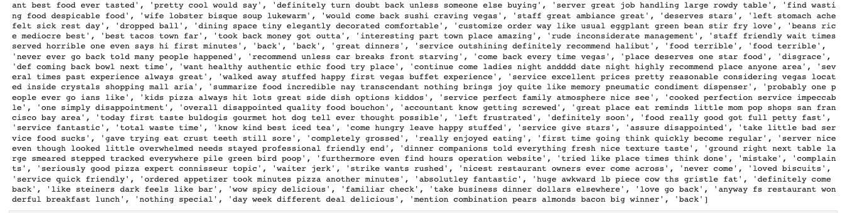

B4. Sentiment Categories

Sentiment categories in this assignment were 0 for negative and 1 for positive.

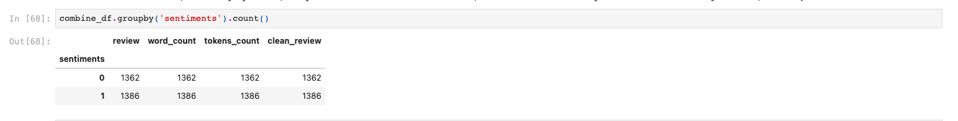

B5. Data Preparation Steps

Put in the required applications

Fill the Pandas data frame with three data sets.

Show the data frame

Analyze the data structure to better comprehend the supplied data

Examine individual DataFrames information from Amazon;

Examine individual DataFrames information from IMDB;

Combine the three files with review labels into one

Revalidate the column, detect missing data, and check for null values.

Verify the combined data frames.

Verify combined data frame information.

Verify combined data frame columns.

Verify combined data frame type.

Verify data types of features.

Verify binary rating (0 = negative, 1 = positive).

Verify positive and negative reviews from combined DataFrame.

Verify ratings' sentiment distribution.

Describe dataset statistics.

Searching for the emoji ":D"

Find vocabulary size, recommended word embedding length, and the number of unique words in the data frame.

Check the length of unique words.

Check the length of the shortest review.

Check the length of the longest review.

Check the total length of all reviews.

Check for odd characters.

Tokenize words using the tokenize function.

Tokenize the review's text.

Print the first 10 reviews.

Verify the word tokens type.

Check out sample review #6.

Replace all capital letters with lowercase letters, remove all numbers from clean review, replace all special characters (choose list), remove stop words, and remove particular terms that appear in both good and bad reviews. Count the number of tokens in each tokenized review.

Check to see review sample no.6:

visualization (positive and negative reviews)

Prepared data set copy: combine_df_prepared_nlp.csv

Next Step

The tokenization procedure, step two

Dividing the dataset

Divide the data set in training and testing by 80/20.

Create the divide after tokenization.

Establish vocab training settings. Train using 2200 words and 16 dimensions.

Each review's maximum length is 100 words; it truncates after 100 words; padding is applied at the conclusion; and it has a tokenizer that fits a train set.

Padding Procedure

Sequence setting and padding

Padded sentences

Sentiment Subtypes

Step 4: Copy the prepared data set to a new file, combine_df_prepared_nlp.csv.

B6. Prepared Dataset

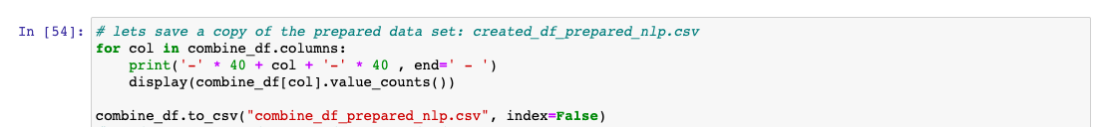



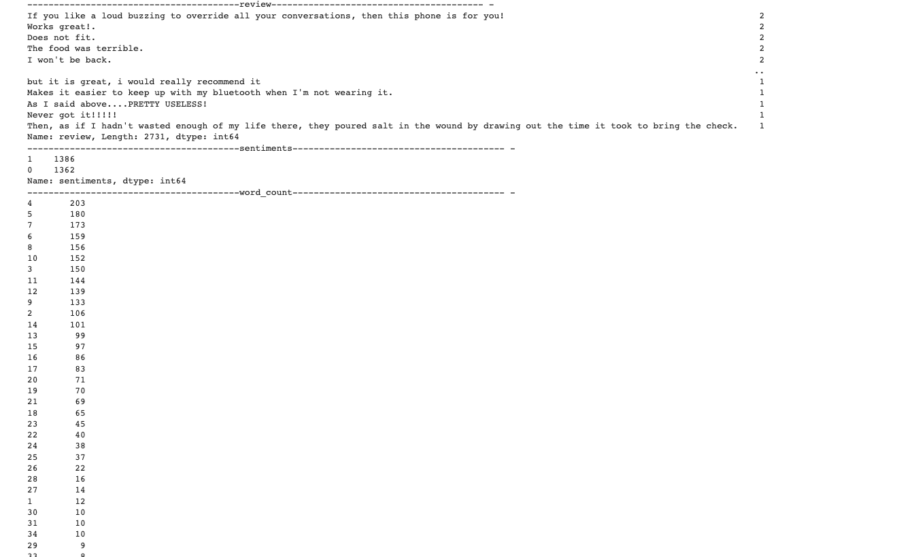

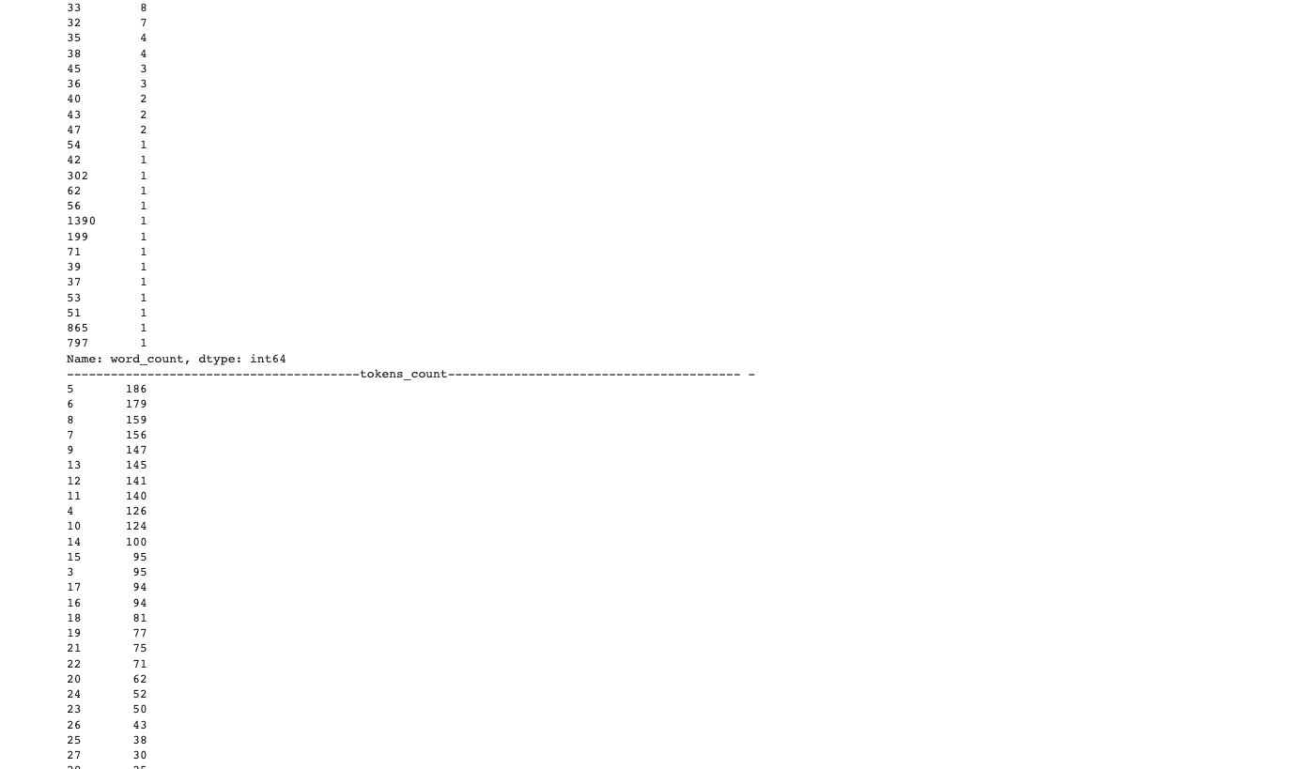

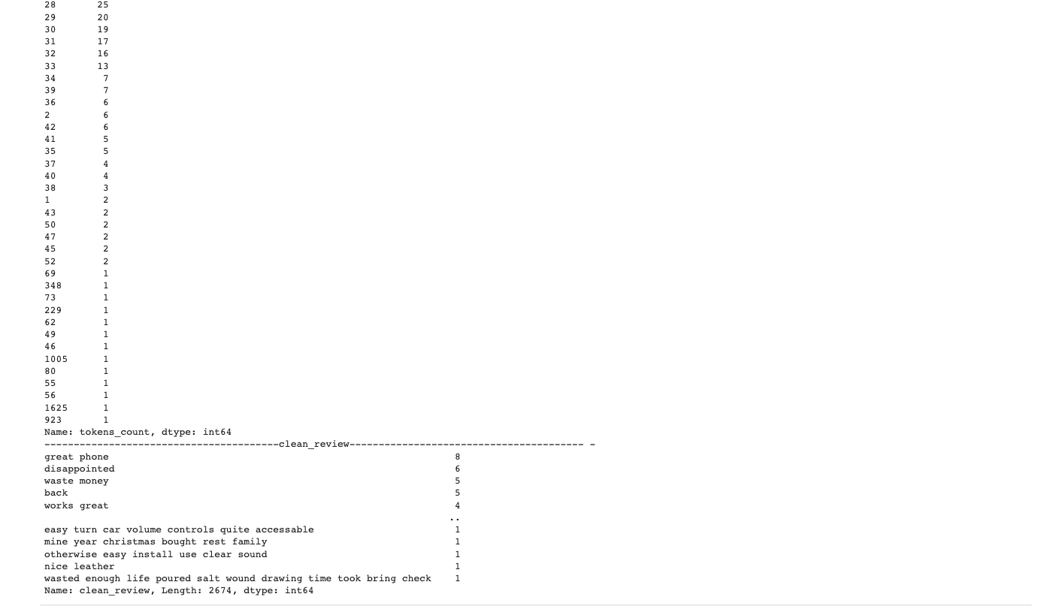

Part 3: Network Architecture

C1. Summary

We use TensorFlow to build the Keras model.

• Binary values of 0 and 1 for favorable and negative reviews.

• The embedding layer, where the parameters are defined.

• The 2D object's GlobelAveragePooling1D is set to output.

• The Third layer is activated with 'relu' and 10

• The fourth layer is activated with 'relu' and set to 6

• The fifth layer is activated with a' sigmoid' setting of 1

Please refer to the result of the TensorFlow function model below.

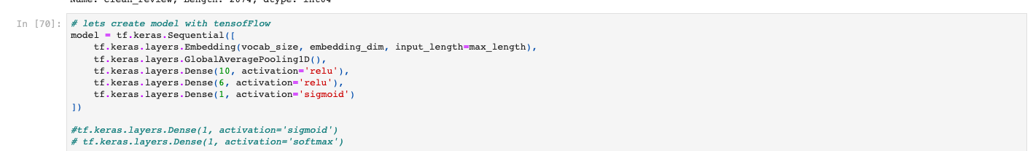

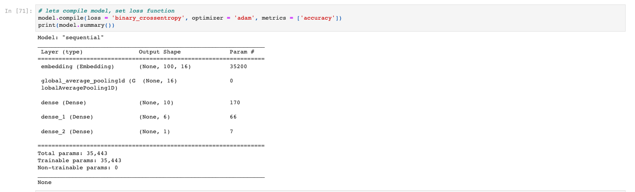

C2. Discussion on Network Architecture

The model's layer count: we utilized five layers.

Layer kinds:

• The embedding layer (None, 100, 16), where the parameters are defined. The total number of parameters is 35200; the vocabulary size is 2200 words, the maximum sentence length is 100 words, and the dimension is 16.

• The 2D object is output by the GlobelAveragePooling1D layer (None, 16), with a parameter total of 0.

• The third layer is buried (Dense), with'relu' activation set to 10, and the parameter value set to 170.

• The parameter total for the fourth layer is 66; it is buried (Dense) and set to'relu' activation with 6.

• The parameter total is 7, the fifth layer is concealed (Dense), and the activation mode is set to "sigmoid." Number of parameters overall: The parameter's overall sum is 35443, its trainable portion is 35443, and its untrainable portion is 0.

C3. Explain the hyperparameters

To improve efficiency and generalisation over bigger datasets, we employed "relu" activation as our activation function. According to Pius, the'relu' function's principal purpose is to apply a threshold operation to each input element, setting values lower than zero to zero. (Pius, 2019).

For the last layer, which is equivalent in the binary classification issue, we utilize "sigmoid" activation.

We employed ten nodes in the third hidden layer, six in the fourth, and one in the final layer.

Loss function: For probabilistic loss, we employed the binary crossentropy loss function.

We utilized the optimizer "adam." Adam is "an addition to the gradient descent optimization method" that is "intended to accelerate the optimization process, for example, minimize the number of function evaluations necessary to achieve the optimum, or to enhance the capabilities of the optimization algorithm."  (Browlee, 2021).

Stopping criteria: we used the EarlyStopping hyperparameter to stop training the data set when performance begins to degrade.

Evaluation metric: To determine how closely the measured value resembles the known value, we utilized the "accuracy".



Part IV: Model Evaluation

D1. The Effects of Using Stopping Criteria

First, 15 epochs of the model were fitted. 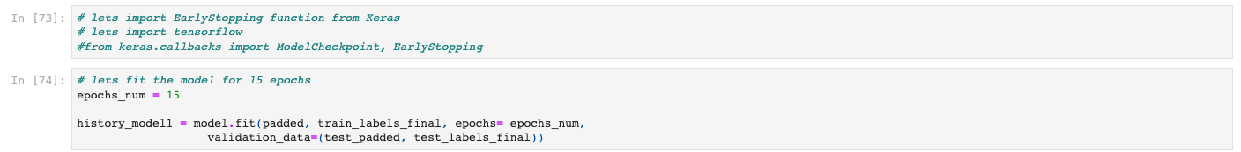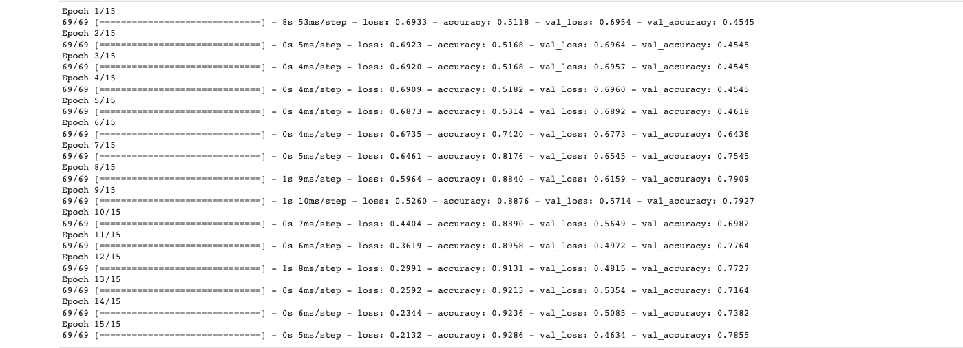

We fit the model over a period of 15 epochs, and the accuracy is shown to be 0.5168 in the first epoch and remain constant through the first to the fourth. The first loss is 0.6929, while the second era sees a decline to 0.6918. We utilize the EarlyStopping hyperparameter to halt training the data set when performance declines in order to avoid overfitting.

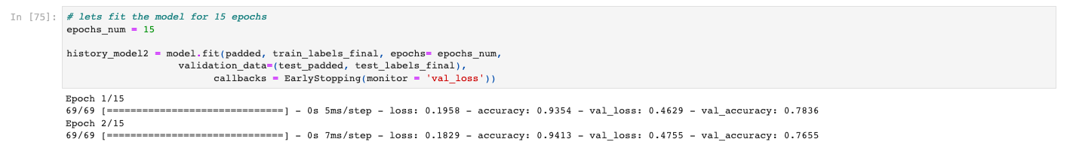

The model has now stopped at 2, indicating that running 2 experiments is the ideal quantity. With an accuracy of 0.93, a val accuracy of 0.79, and a loss of 0.19, our model avoids overfitting and terminates after 2 epochs. Based on terms in customer reviews, our prediction algorithm is 93% accurate in predicting consumer sentiment.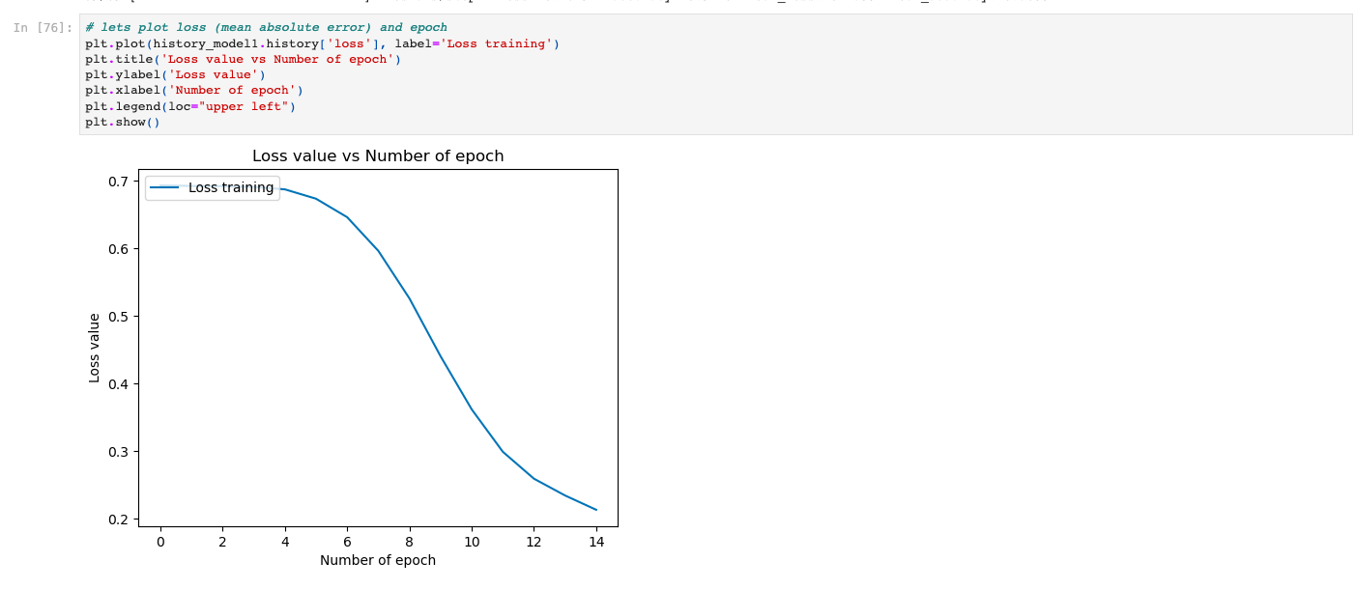

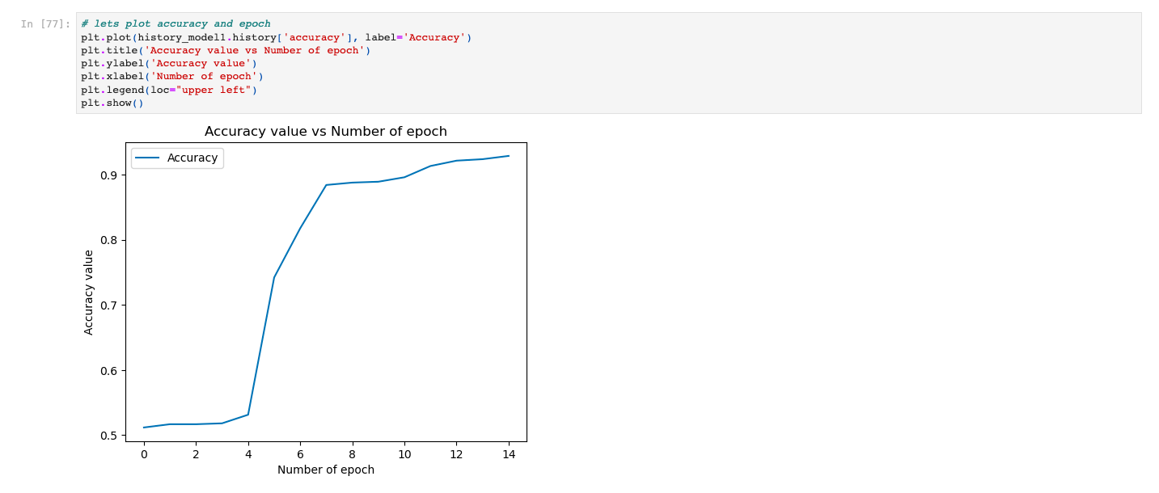

D2. Training Process for Visualizations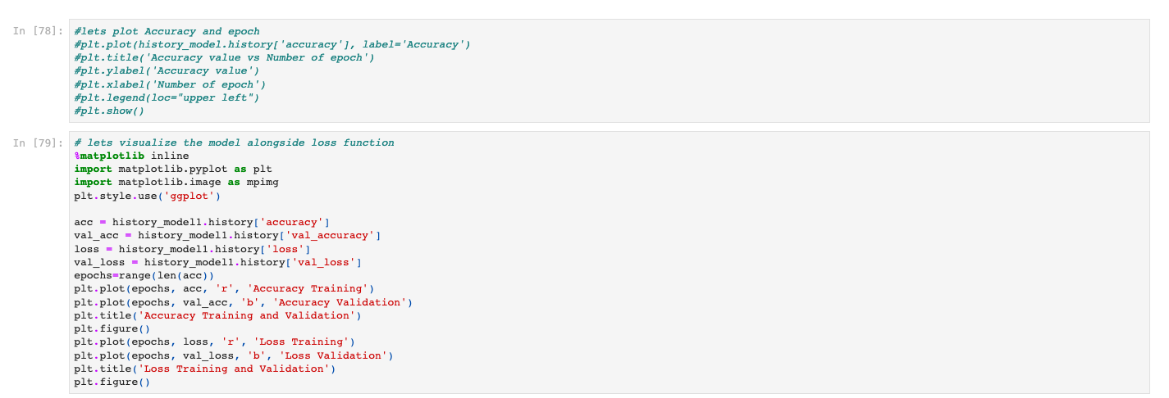

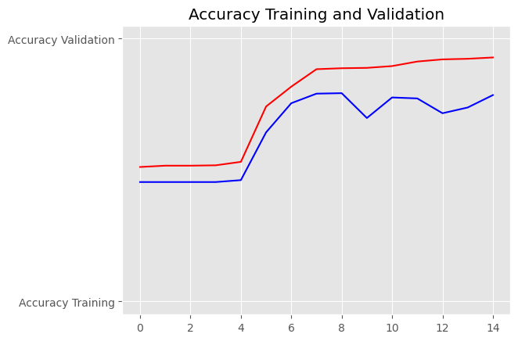

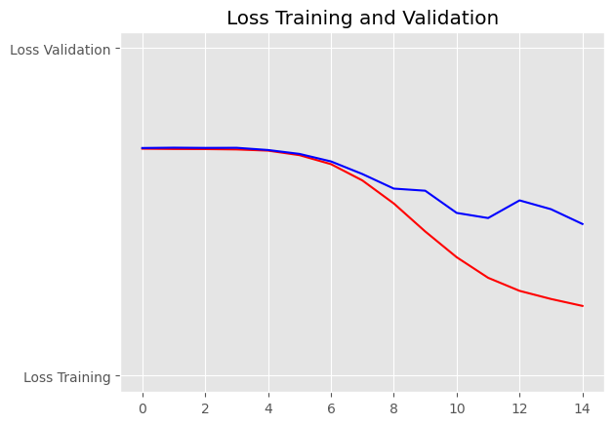

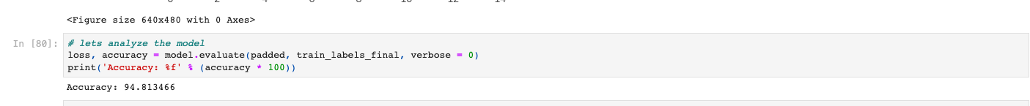

D3. Model Fitness

The emotion is straightforward with a simple vocabulary size of 2200 and a scale of 1 to 0 for positive and negative feedback. To avoid overfitting, improve accuracy, and minimize loss, we employed early stopping. The model stops at 2, which indicates that running 2 experiments is the ideal quantity. With an accuracy of 0.93 and a val accuracy of 0.79, our model avoids overfitting and terminates after two epochs. Based on terms in customer reviews, our prediction algorithm is 93% accurate in predicting consumer sentiment.

D4. Reliable Prediction

We obtained a solid model with a 93% accuracy and a 79% val accuracy. Based on terms in customer reviews, our prediction algorithm is 93% accurate in predicting consumer sentiment.

Part V. Summary and Recommendations

E. Codes

For the whole code, please refer to the Jupyter notebook pdf that is attached and the code above.F. Functionality

To create the model that would predict the tone of upcoming customer reviews based on previously provided labeled datasets, we will utilize the Python TensorFlow library. The objectives of the data analysis were learning and evaluating the consumers by determining their favorite product based on favorable product reviews. Can we predict the viewpoint of incoming customer evaluations using neural networks, and particularly natural language processing (nlp), utilizing past sentiment tagged sets of data? This is our research question. Yes.

We construct the sequential model with 5 layers after preparing and cleaning the pooled dataset. We had the final prediction model with an accuracy of 93% in predicting consumer emotion since we had set the training and testing with the stop point to assist us avoid overfitting and boost the accuracy. This is an excellent model result, and we can use the model to predict whether reviews will be positive or negative.

G. Activity

According to the outcome, the model's accuracy is high (93%). This is a useful model for predicting the tone of upcoming customer evaluations. The company may forecast future sales and even determine the customer's favored product from a favorable review based on the vocabulary size in the review. Based on such information, the business can then take appropriate action.

Part VI . Reporting

1. Jupyter notebook in pdf format

2. Microsoft Word document

3. Finished data sets

4. First datasets

I. Sources for third-party code

Gaurav Dutta (2021). *Sentiment Analysis on Amazon Title Review***.**

<https://www.kaggle.com/code/gauravduttakiit/sentiment-analysis-on-amazon-title-review>

MonkeyLearn. (n.d). *Sentiment Analysis: A Definitive Guide*.

<https://monkeylearn.com/sentiment-analysis/>

Anis Agmad. (n.d). *Getting Started with Sentiment Analysis using Python*. <https://cnvrg.io/sentiment-analysis-python/>

KidAperture. (2021, September 21). *D213-Advanced-Data-Analytics*. <https://github.com/KidAperture/D213-Advanced-Data-Analytics/blob/main/D213_task2.ipynb>

J. Acknowledge source

FreeCodeCamp.org. (2019, September 16). *TensorFlow 2.0 Crash Course*. <https://www.youtube.com/watch?v=6g4O5UOH304>

Paul Sayak. (2021, May 17). *Python Sentiment Analysis Tutorial.* <https://www.datacamp.com/community/tutorials/simplifying-sentiment-analysis-python>

Tal Perry. (2021, February 01). *What is Tokenization in Natural Language Processing (NLP)*?. <https://www.machinelearningplus.com/nlp/what-is-tokenization-in-natural-language-processing/>

Brownlee Jason, (2021, January 13). *Code Adam Optimization Algorithm From Scratch*. <https://machinelearningmastery.com/adam-optimization-from-scratch/>